

Equality, Diversity and

Inclusion Policy for

The Teignbridge

Community Project

CIC

Equality, Diversity and Inclusion Policy

The Directors of The Teignbridge Community Project CIC, are responsible for ensuring that those benefiting from us or working with us are not harmed in any way. The Directors of The Teignbridge Community Project CIC, have a legal duty to act prudently, and this means that they must take all reasonable steps within their power to ensure that no one is harmed. It is particularly important where beneficiaries are vulnerable persons or children in the community.

This policy applies to all those involved in The Teignbridge Community Project CIC, including, but not exclusively, Directors, Management, Team Leaders, Employees, Contractors , Volunteers and Service Users.

The Teignbridge Community Project CIC, is committed to encouraging equality, diversity, and inclusion among our workforce and facilities, and eliminating unlawful discrimination.

The aim is for our workforce to be truly representative of all sections of society and our service users and employees to feel respected and able to give their best.

The organisation - in providing goods and/or services and/or facilities - is also committed against unlawful discrimination of customers or the public.

Our policy’s purpose

This policy’s purpose is to:

1. Provide equality, fairness and respect for all in our employment, whether temporary, part-time or full-time.
2. Provide equality, fairness and respect for all our service users and clients.
3. Not unlawfully discriminate because of the Equality Act 2020 the protected characteristics of:

* age
* disability
* gender reassignment
* marriage and civil partnership
* pregnancy and maternity
* race (including colour, nationality, and ethnic or national origin)
* religion or belief
* sex
* sexual orientation

4. Oppose and avoid all forms of unlawful discrimination. This includes in:

* pay and benefits
* terms and conditions of employment
* dealing with grievances and discipline
* dismissal
* redundancy
* leave for parents
* requests for flexible working
* selection for employment, promotion, training or other developmental opportunities

Our commitments

The Teignbridge Community Project CIC commits to:

1. Encourage equality, diversity and inclusion in the workplace as they are good practice and make business sense.

1. Create a working environment free of bullying, harassment, victimisation and unlawful discrimination, promoting dignity and respect for all, and where individual differences and the contributions of all staff are recognised and valued.

This commitment includes training managers and all other employees about their rights and responsibilities under the equality, diversity and inclusion policy.

Responsibilities include staff conducting themselves to help the organisation provide equal opportunities in employment, and prevent bullying, harassment, victimisation and unlawful discrimination.

All staff should understand they, as well as their employer, can be held liable for acts of bullying, harassment, victimisation and unlawful discrimination, in the course of their employment, against fellow employees, service users, customers, suppliers and the public.

1. Take seriously complaints of bullying, harassment, victimisation and unlawful discrimination by fellow employees, service users, customers, suppliers, visitors, the public and any others in the course of the organisation’s work activities.

Such acts will be dealt with as misconduct under the organisation’s grievance and/or disciplinary procedures, and appropriate action will be taken. Particularly serious complaints could amount to gross misconduct and lead to dismissal without notice.

Further, sexual harassment may amount to both an employment rights matter and a criminal matter, such as in sexual assault allegations. In addition, harassment under the Protection from Harassment Act 1997 – which is not limited to circumstances where harassment relates to a protected characteristic – is a criminal offence.

1. Make opportunities for training, development and progress available to all staff, who will be helped and encouraged to develop their full potential, so their talents and resources can be fully utilised to maximise the efficiency of the organisation.

1. Make decisions concerning staff being based on merit (apart from in any necessary and limited exemptions and exceptions allowed under the Equality Act).

1. Review employment practices and procedures when necessary to ensure fairness, and also update them and the policy to take account of changes in the law.

1. Monitor the make-up of the workforce regarding information such as age, sex, ethnic background, sexual orientation, religion or belief, and disability in encouraging equality, diversity and inclusion, and in meeting the aims and commitments set out in the equality, diversity and inclusion policy.

Monitoring will also include assessing how the equality, diversity and inclusion policy, and any supporting action plan, are working in practice, reviewing them annually, and considering and taking action to address any issues.

Agreement to follow this policy

The equality, diversity and inclusion policy is fully supported by the Directors, and has been agreed with trade unions and/or employee representatives at The Teignbridge Community Project CIC.

Our disciplinary and grievance procedures

Details of the organisation’s grievance and disciplinary policies and procedures can be found at The Teignbridge Community Project CIC. Please ask Anna Lofthouse. This includes with whom an employee should raise a grievance – usually their Team Leader.

Use of the organisation’s grievance or disciplinary procedures does not affect an employee’s right to make a claim to an employment tribunal within three months of the alleged discrimination.

Appointed Person

An appointed person should be known to staff and clients alike; as the designated person to whom concerns should be addressed.

The appointed person at The Teignbridge Community Project CIC is: Anna Lofthouse

Contact Number: 07445158419

If the concern is about this designated person, please report to: Anna Lofthouse

Contact Number: 07445158419

Reviewed: 1st July 2025

Next Review: 1st July 2027

Signed:

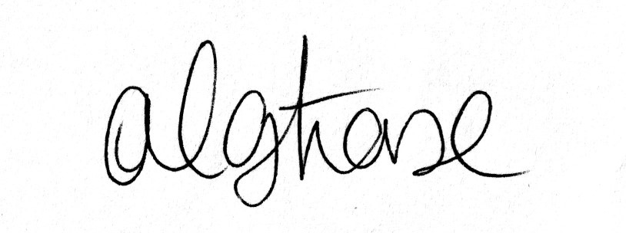 Date: 1st July 2025