

Vulnerable Adult and Child Friendly Safeguarding Policy

This ‘Vulnerable Adult and Child Friendly’ policy is designed just for you, and this should be read as a guide to The Teignbridge Community Project’s main policies.

This policy is to help you decide what could be a ‘problem’ and where to get help and support.

Is someone bullying you or making you feel sad?

You must tell someone at The Teignbridge Community Project so we can help you.

Examples of people you can tell at The Teignbridge Community Project are:

• Anna, and any adults who work for us. They will find someone who can help you.

Do NOT keep it a Secret! You must tell someone so we can help you.

Do NOT keep it a secret! Has someone asked you if you want a tablet or to smoke a cigarette, or have a drink of something and you do not know what it is?

Do not eat, drink or smoke what they are giving you. You must tell someone at The Teignbridge Community Project so we can help you.

Has someone hit, punched or smacked you?

There are many staff for you to talk to and they will help support you.

Talk to someone.

Sometimes a member of staff at The Teignbridge Community Project will need to check things then if they can deal with the issue themselves, they will. There are times though when they may need to contact some other agencies for support. These may be Children’s Social Care (Social Workers) or Police. There are lots of other agencies who support children and their families as well.

Appointed Person

An appointed person should be made known to staff, volunteers and service users alike; as the designated person to whom concerns should be addressed.

The appointed person at The Teignbridge Community

Project is: Anna Lofthouse Contact number: 07445158419

If the concern is about this designated person, please report to: Noreen Jordan

Contact number: 07787368168

Designated Safeguarding Lead for The Teignbridge

Community Project is: Anna Lofthouse

Deputy Designated Safeguarding Lead for The

Teignbridge Community Project is: Noreen Jordan

Reviewed: 1st July 2025

Next Review: 1st July 2027

Signed:

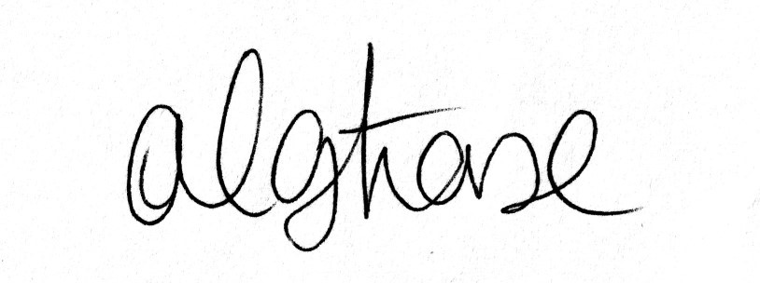 Date: 1st July 2025

Anna Lofthouse, Director